Press Release
noax S19P Steel PCAP Touch Industrial PC: Ready for the challenges of Industry 4.0

Following the success of the Red Dot Award-winning S21WP, noax Technologies AG presents the new S19P PCAP Industrial PC. With its tried and tested noax quality and ruggedness, as well as state-of-the-art technology and elegant aesthetics, the S19P is scoring top marks. The 19” TFT display allows intuitive, smartphone-oriented gesture operation with a resistant, multi-touch screen made of tempered safety glass. In addition, the touch sensitivity can be adjusted directly by the customer, individually and intuitively, depending on the application.
The digitization of production environments is making great strides forward. A major key to success is the ability to improve a company’s competitiveness by faster, more flexible, and more efficient production options. Information must be available at the right time and at the right place with durable and rugged information technology as the foundation.
With the new S19P PCAP Industrial Computer, noax Technologies AG presents the Industry 4.0 IPC. The completely sealed, finely polished, stainless steel V2A housing of the S19P industrial PC shares the successful look of the award winning S21WP. Certified up to protection class IP69K, the S19P Industrial Computer is ideal for use in locations with strict hygiene requirements or demanding industrial conditions.

Revolutionary touch technology with glove operability and touch sensitivity adjustment
The S19P Industrial PC with PCAP touch technology allows the use of multiple fingers at the same time. The intuitive gesture control is based on a unique touch sensitivity previously not available in an industrial environment. The noax nSMART tool can be used to adjust the touch sensitivity fast and easily to suit your application. Preset options are available to help you make the selection. Intuitive operation with maximum use of the screen surface is ensured, with or without gloves and regardless of a wet or dry environment.
Thus, the noax S19P Industrial PC offers an optimal balance between minimal space requirement and user-oriented, user-friendly, and manageable operation along with state-of-the-art technology. For more information go to www.noax.com.

Images:
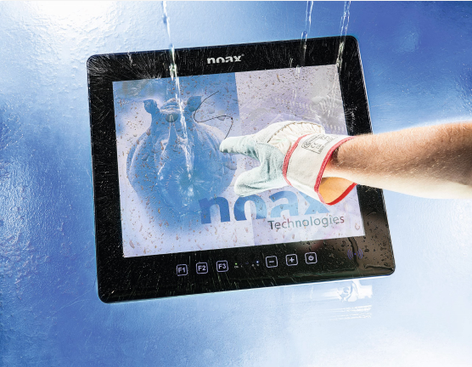

Caption: The new noax S19P Steel PCAP Touch Industrial PC in finely polished stainless steel V2A housing – externally certified up to protection class IP69K.

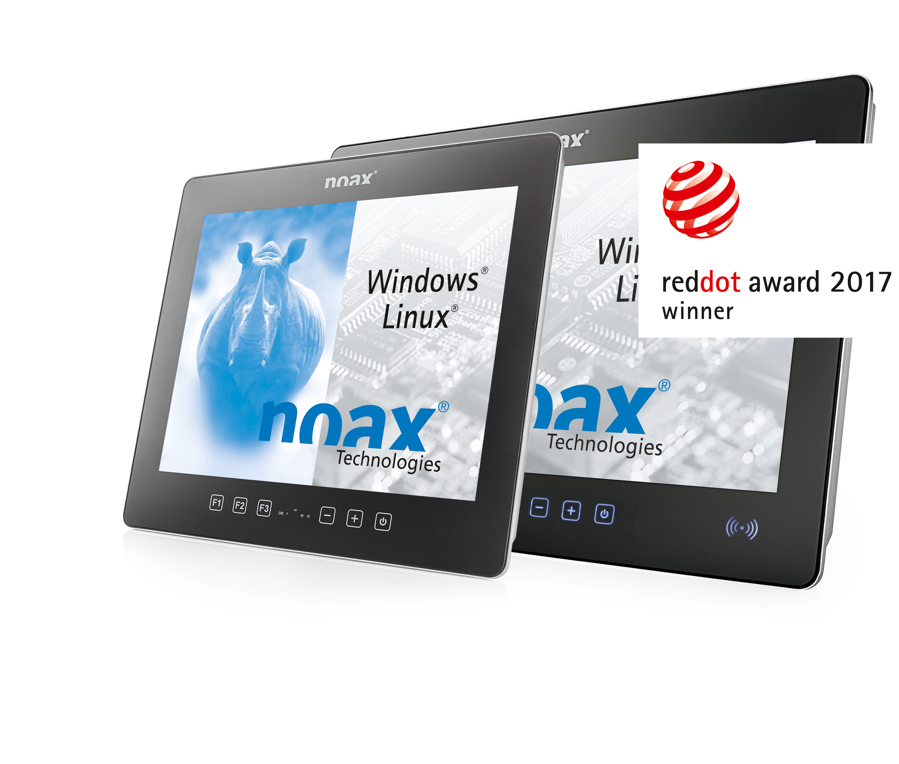

Caption: The new noax S19P Steel PCAP Touch Industrial PC for demanding industrial applications.

About noax Technologies AG
noax Technologies AG ranks among the world’s leading manufacturers of high-end, rugged and reliable industrial PCs. The company has over 25 years of experience in developing and producing completely sealed systems. noax also offers its customers a full spectrum of services ranging from consultation and sales to installation and comprehensive support. noax industrial PCs are used all over the world in the most demanding of industrial environments at well-known companies in the automotive, logistics, food processing, and chemical industries, amongst others. These computers were developed specifically for industrial use and prove their resistance to heat, cold, moisture, dust, vibration, and shock on a daily basis.

Reproduction permitted.

Please send us a copy.

Feel free to contact us if you have questions:

noax media contact:

LEAD Industrie-Marketing GmbH
Anita Geßner Tel.: +49 80 22 - 91 53 188
Hauptstr. 46 Fax: +49 80 22 - 91 53 189
D-83684 Tegernsee Email: anita.gessner@lead-industrie-marketing.de

